**SUMMARIZATION**

[IEEE Research Paper Summary]

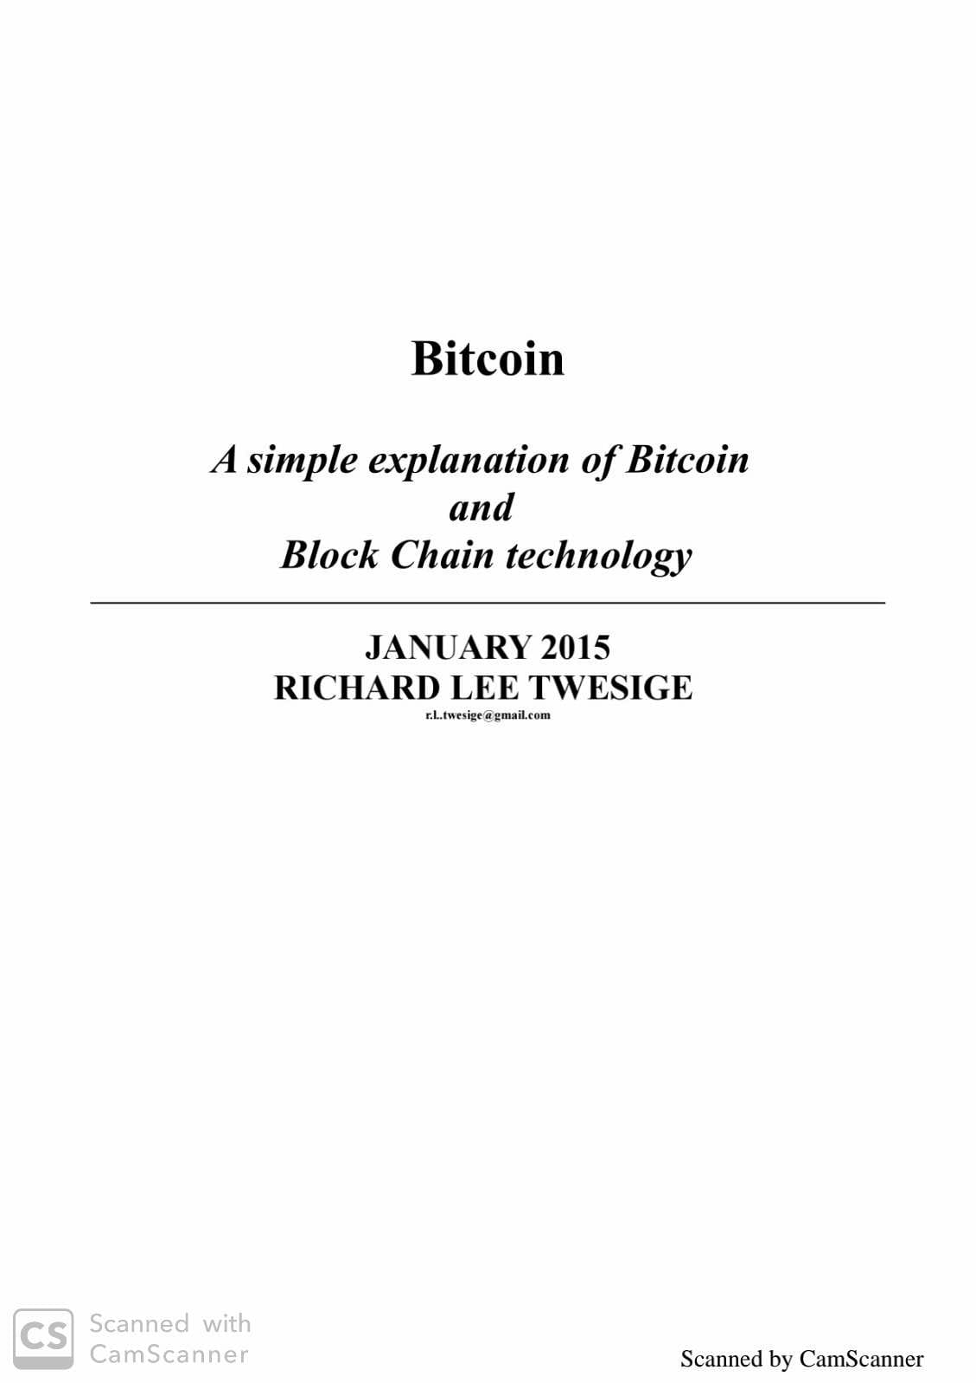[Bitcoin]

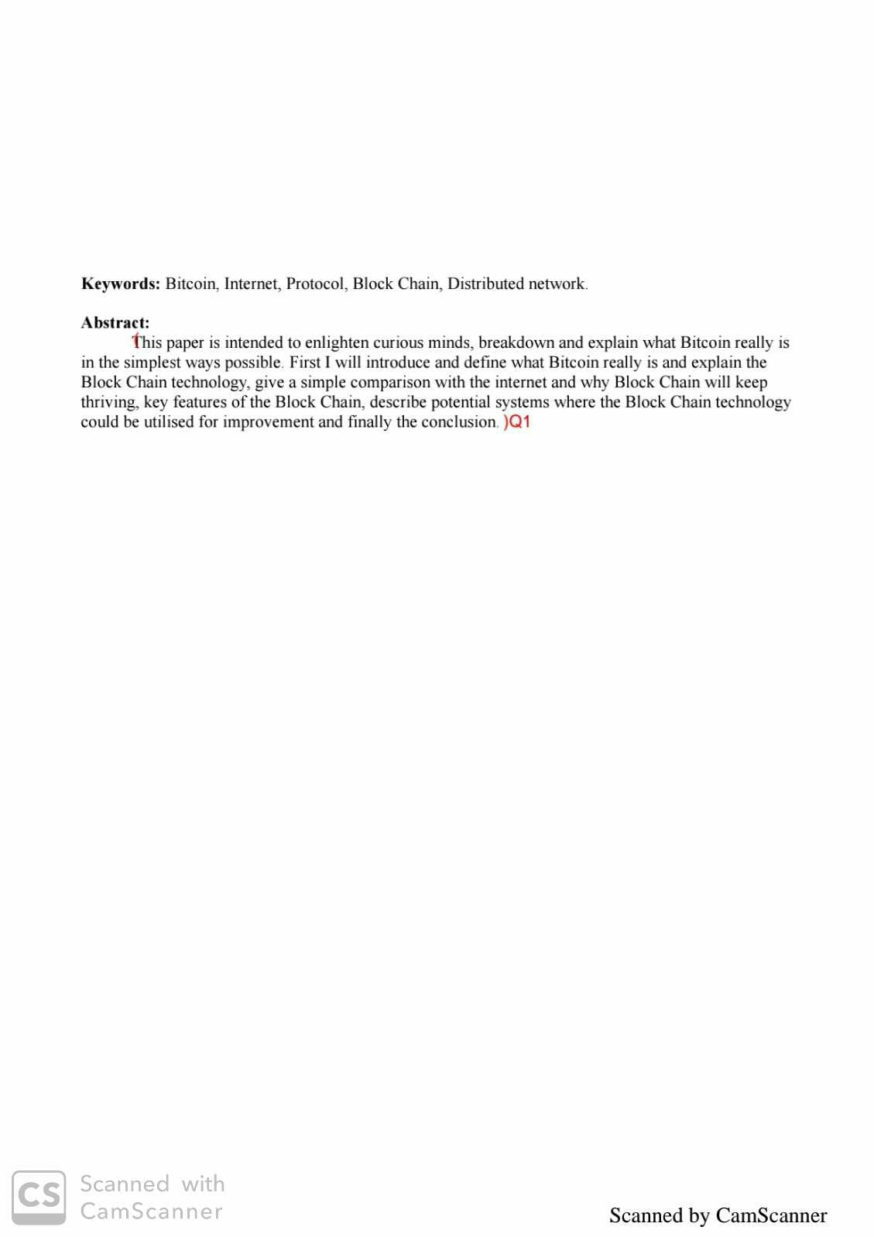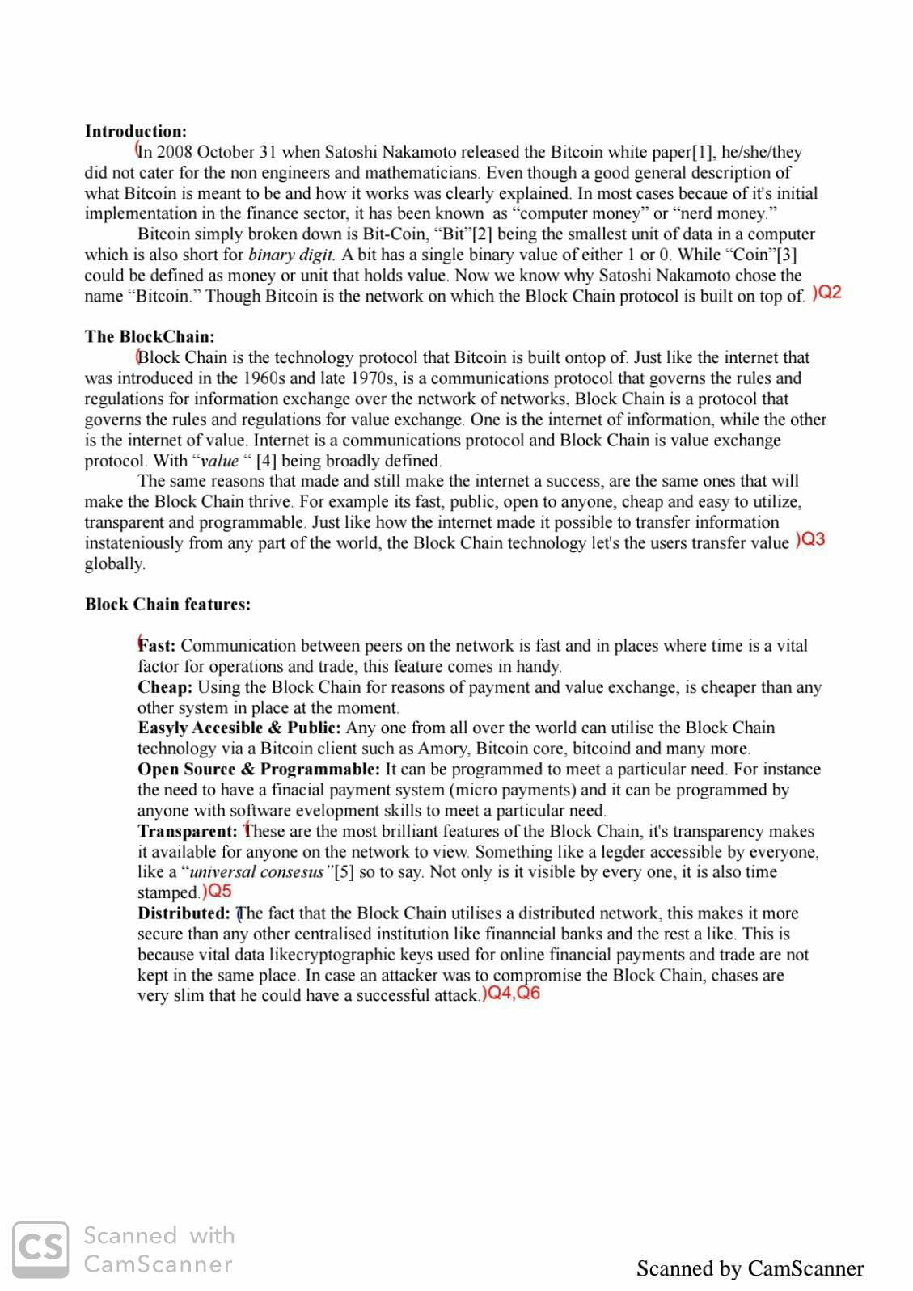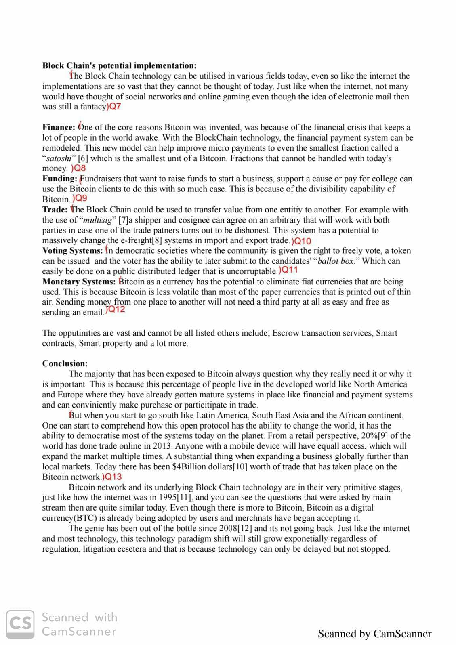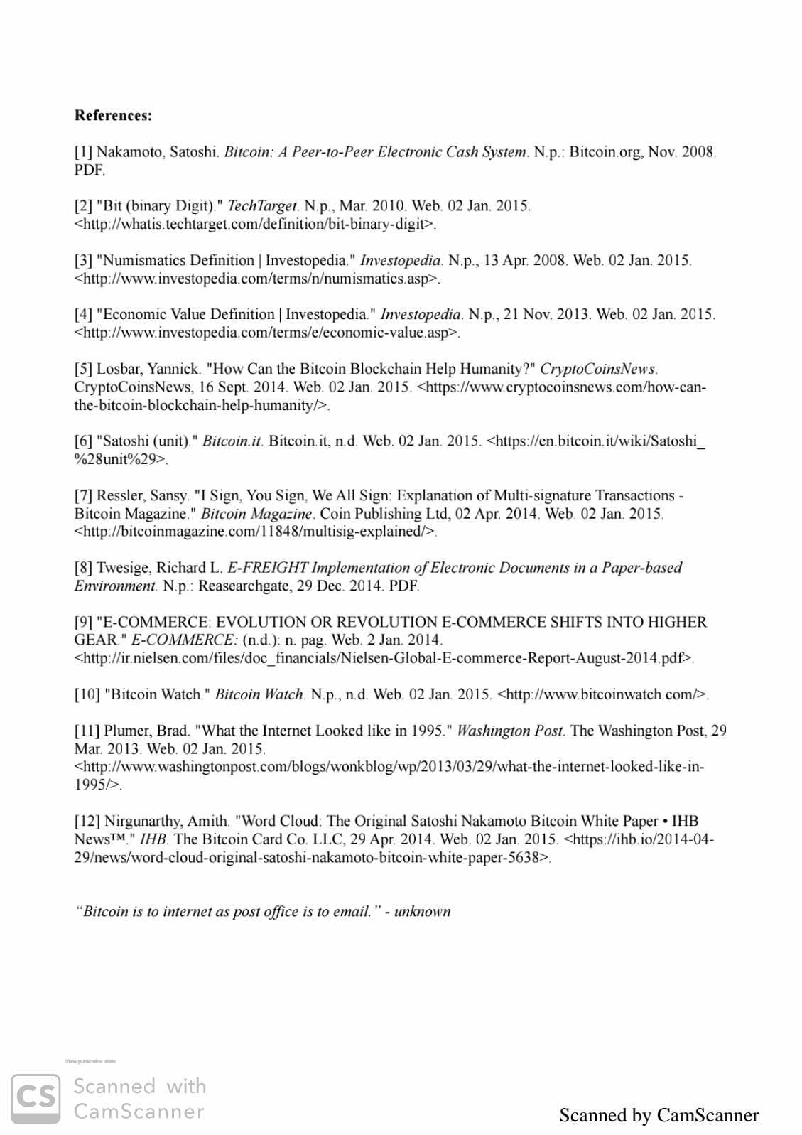

**Questions:**

Q1) What is the purpose of this paper ?

Q2) What happened during inception of Bitcoin ?

Q3) What are some of the similarities between Internet and Block Chain ?

Q4) What are some of the features of Block Chain ?

Q5) Explain the transparency feature of Block Chain ?

Q6) Explain why Block Chain is more secure than traditional financial institutions ?

Q7) Why is it hard to predict the potential implementation of Block Chain technology ?

Q8) How is Bitcoin remodeling the financial world ?

Q9) How is crowdfunding made easier with Bitcoin ?

Q10) How does Bitcoin make trading safer ?

Q11) How can Blockchain technology improve the voting system ?

Q12) How can Bitcoin make monetary systems more stable ?

Q13) How can Bitcoin help accelerate the growth of global market ?

**SUMMARIZATION**

[Point Summary]

[Assignment No.6.1]

* To enlighten people about the wonders of blockchain technology , to demystify it and discuss its possible applications in various fields.
* Satoshi Nakamoto released the conceptual idea of Bitcoin in 2008 on white paper. As its early application mainly saw it being used in finance sector , it came to be known as “computer money” or “nerd money”. Bitcoin derived its name from “bit” ,which is the smallest unit of date in a computer . A bit has a single binary value of either 1 or 0.
* Internet is a communication protocol which governs the rules and regulations for information exchange over the network of networks , similarly Block Chain is a protocol that governs the rules and regulations for value exchange . Internet can be thought of as an internet of information while Block Chain is internet of value . Internet is communication protocol while Block Chain is value exchange protocol. Both are fast, public, open to anyone, cheap and easy to utilize, transparent and programmable. Just like Internet facilitates information transfer, Bitcoin facilitates value transfer.
* Features of Block Chain are :
* Fast communication between peers is possible, which in turn allows fast operations and trade.

It is cheaper than any other mode of transaction out there.

It is easily accessible to anyone through Bitcoin clients like Amory, Bitcoin core, bitcoind and many more.

It is open source and can be programmed by anyone with software development skills.

It is completely transparent in its working , which means that anyone can access its ledger and this ledger is also time stamped.

It is the most secure way to carry out a transaction as it is completely decentralized and for it to be compromised under an attack, the attacker would require to have access to over 50% of the distributed network system.

* Transparency is one of the key features of Block Chain technology . It is completely transparent in its working , which means that anyone can access its ledger and this ledger is also time stamped.
* Unlike traditional financial institutions , Block Chain is completely decentralized , which completely eliminates the risk of fraudulent transactions .
* Since Block Chain technology is so versatile its hard to predict its uses with our current technology . Just like during the early stages of internet it was impossible to predict the inception social media , its currently impossible to predict all the future technologies that could be birthed out of Block Chain.
* Bitcoin is completely decentralized, which allows for trading at global scale . The transactions taking place through Bitcoin allow for micro payments which are not possible through traditional banking system.
* Collecting money for charity or any sort of crowdfunding is made easier with Bitcoin because of its divisibility capabilities and direct client to client transaction
* Bitcoin has a feature called “multisig” which allows for direct user to user transactions , with arbitrary conditions set in place and during a fraudulent transaction the contract can be nullified by the party.
* All eligible voters can be issued a voting token and during the voting process the voter can then submit this token to their candidates “ballot box” . This entire process will be conducted on a public ledger anonymously . This transparency would help avoid any corruption during the voting process .
* Bitcoin has the capability to eliminate all of the fiat currencies being used right now. Bitcoin is far less volatile than currencies of underdeveloped nations and hence its use in transaction could help stabilize such countries economies . Bitcoin also gets rid of any third party making it the easiest and cheapest form of currency .
* The markets in underdeveloped nations is largely unutilized because of several factors , but the open protocol of Bitcoin has the ability to change that and democratize it . This would give retailers an unprecedented freedom to carry out their business . Since Bitcoin is not backed by any centralized power it could help expand the market multiple times and in turn help businesses grow globally further than local markets. Today there has been 4 Billion dollars worth of trade been taken place on the Bitcoin network .